Xenon RFDB Guide
RF Receiver Dongle and Programming Guide



Change list
文件版本 | 變更說明 | 編修 | 日期
v0.1 | 初版發行 |  | 2011/03/17
v0.2 | 加入圖表說明 | 李涵 | 2019/02/27
v0.3 | 部分文字編修 | tbjk | 2019/2/28

Features
‧Designed for digital data wireless transmission automatically
‧Radio Frequency Data Buffer (RFDB) design, 100% data transmission
‧USB interface
‧Designed for digital data wireless communication

Applications
‧Home care device wireless communication
‧MCU-base product wireless communication

I. Xenon RF Receiver Dongle
- OVERVIEW
Xenon RF receiver dongle is a Xenon Radio Frequency Data Buffer (RFDB) receiver. It can receive RF data from Xenon module. It uses Nordic’s nRF2401+ chip as main function and radio frequency control unit.

- MECHANICAL DIMENSION (Unit：mm)

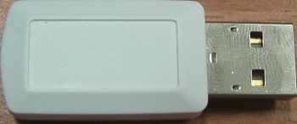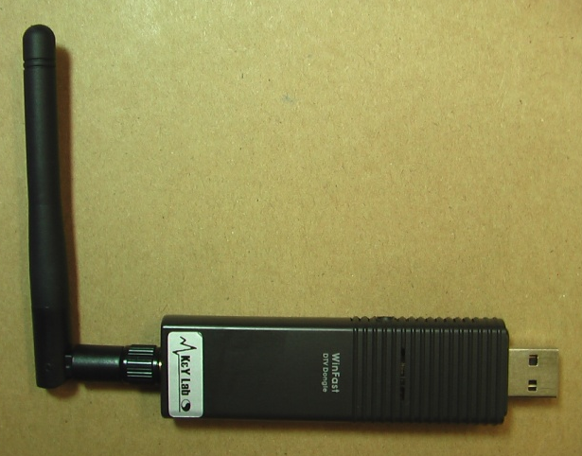
18mm
100mm

45mm
125mm
Xenon SS14J1 Dongle
Xenon SS14L1 Dongle
II. Xenon Data Buffer Receiver Programming Guide
- SOFTWARE SETTINGS
The communication use UART protocol and the setup parameters are present as follow.
Baud rate | 250000
Data bit | 8
Parity | No
Start bit | 1
Stop bit | 1

- PROGRAMMING FLOW CHART
The program follows the procedure of (1) Confirm the communication (2) Set up RFDB function (3) Set up transmit settings (4) Start function.

Confirm Communication:
Command: 0x00.

Return = 0x4B
Pull RTS high to reset comport then confirm communication again.

No

Yes

Every package with 32 bits header.
Every package without 32 bits header.

Set RFDB function:
Command: 0x28
No return.
Set channel:
Command: 1 byte channel. No return.
Set RFDB function:
Command: 0x23
No return.

Set channel:
Command: 1 byte channel. No return.

- COMMANDS

3.1 Commands and Parameters
The commands and parameters should input 1 byte by 1 byte when programming.

3.1.1 Confirm Communication

 | Command Byte
Byte index | Byte 1
Value | 0x00
Return Value(1 byte) | 0x4B

3.1.2 Setup RFDB Function and Channel (With 32 bits Package Header)

 | Command byte | Channel Number
Byte Index | Byte 1 | Byte2
Value | 0x28 | channel number [1]

3.1.3 Setup RFDB Function and Channel (Without 32 bits Package Header)

 | Command byte | Channel Number
Byte Index | Byte 1 | Byte2
Value | 0x23 | channel number [1]

[1]: The value of this parameter is the number of receiving channel. For example, receiving data form channel 4 then this parameter should be 0x04.

3.2 Example Code
Following example is developed in Delphi environment, in Pascal language。

Example 1: With 32 bits Package Header
ComPort1.SetRTS(true); //reset comport
delay(1);
ComPort1.SetRTS(false);
delay(500);

Cmd_Send($00);
if (read_uart = $4B)
{
//Setup RFDB Function
Cmd_Send($28); // With 32 bits Packet Header
Cmd_Send(Channel); // set RF channel
}
Example 2: No 32 bits Package Header
ComPort1.SetRTS(true); //reset comport
delay(1);
ComPort1.SetRTS(false);
delay(500);

Cmd_Send($00);
if (read_uart = $4B)
{
//Setup RFDB Function
Cmd_Send($23); // Without 32 bits Packet Header
Cmd_Send(Channel); // set RF channel
}

- Xenon RFDB Package

Each Xenon RFDB package contains 4 or 2 (Info and Data) elements, depending on RFDBH flag in the TCP initial packet (see Xenon TCP Guide); they are Header, Info, Data and Checksum. See description blow.
4.1.1 RFDB packet structure
Tag | Description | Length (Bytes) | Reference
Header | Fixed 4 bytes header. | 4 | Table 4.1.2
Info | 4 bytes RFDB information | 4 | Table 4.1.3
Data | 0..7 bytes Device ID and 1..31 bytes Data | Max 38 bytes | Table 4.1.3
Checksum | Sum of Info and Data | 1 | Table 4.1.4

4.1.2 RFDB Header Structure
 | Byte 0 | Byte 1 | Byte 2 | Byte 3
Value | 0x4B | 0xF3 | 0x52 | 0xEC

4.1.3 RFDB Info and Data Structure
RFDB Info |  |  |  | RFDB Data
Product ID |  | Index stamp | Device ID Length (DIDL) and Data Length (DL) | Device ID | Data
Byte 0 | Byte 1 | Byte 2 | Byte 3 | Byte 4 ~ Byte 4+ DIDL-1 ( DIDL ranges from 0 to 7), absent if DIDL is 0 | Byte 4+DIDL ~ Byte 4+DIDL+DL-1 (DL ranges from 1 to 31)
Low byte of  product ID | High byte of  product ID | Package index [3] | See DIDL and DL structure below | Range from 0 to 2^56-1 | Data received from device

[3] Package index increase 1 by every package, range from 0 to 255.

4.1.3.1 DIDL and DL structure
RFDB Info Byte 3
Bit 7 | Bit 6 | Bit 5 | Bit 4 | Bit 3 | Bit 2 | Bit 1 | Bit 0
Device ID Length (DIDL),  Range 0~7 |  |  | Data Length (DL),  Range 1~31

Example 1: 0x00|0x01|0x05|0x24|0x06|0x07|0x08|0x09|0x0A
It means that this package is sent from product ID hex0100, index stamp is 5 and length of device id is 1, length of original data is 4. Device id is 0x06, original data are 0x07|0x08|0x09|0x0A.

Example 2: 0x01|0x00|0x06|0x46|0x06|0x07|0x08|0x09|0x0A|0x0B|0x0C|0x0D
It means that this package is sent from product ID hex0001, index stamp is 6 and length of device id is 2, length of original data is 6. Device id is hex0607, original data are 0x08|0x09|0x0A|0x0B|0x0C|0x0D.

Example 3: 0x00|0x01|0x05|0x05|0x06|0x07|0x08|0x09|0x0A
It means that this package is sent from product ID hex0100, index stamp is 5, no device ID and original data is 0x06|0x07|0x08|0x09|0x0A.

4.1.4 RFDB Checksum
Description | Sum of every byte of RFDB Info and RFDB Data

Example: 0x4B|0xF3|0x52|0xEC|0x00|0x01|0x05|0x05|0x06|0x07|0x08|0x09|0x0A|0x33
RFDBH flag in the TCP initial packet is on. RFDB Header is 0x4B|0xF3|0x52|0xEC. The RFDB Checksum is 0x33, that is sum of 0x00|0x01|0x05|0x05|0x06|0x07|0x08|0x09|0x0A. This package is sent from product ID hex0100, index stamp is 5, no device ID and data is 0x06|0x07|0x08|0x09|0x0A.

